Brendan Richardson

CS 255 System Design Document

UML Diagrams

UML Use Case Diagram
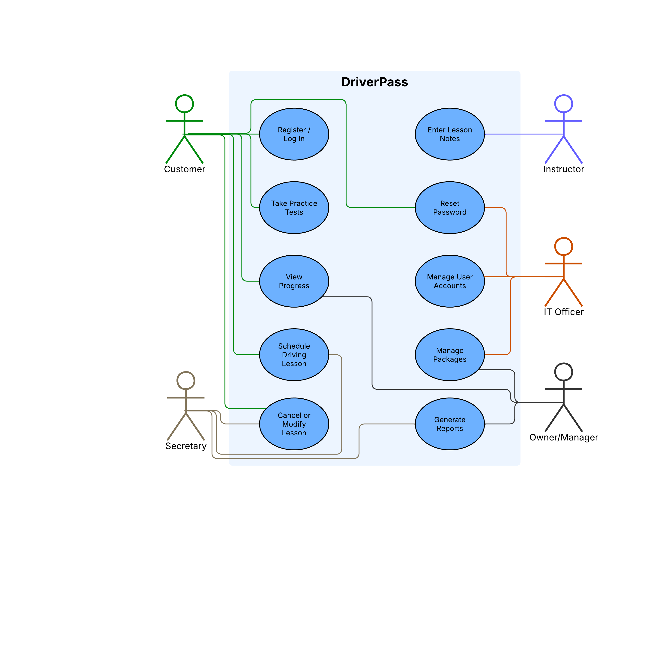

UML Activity Diagrams

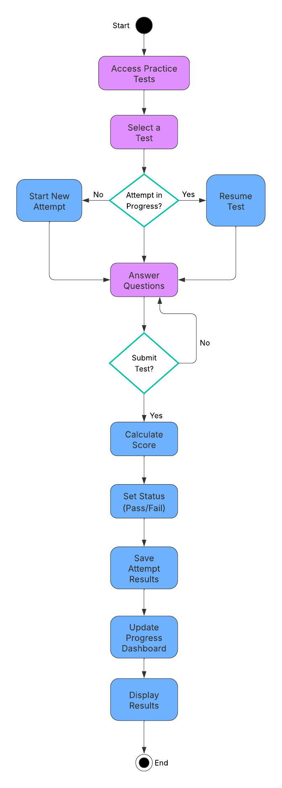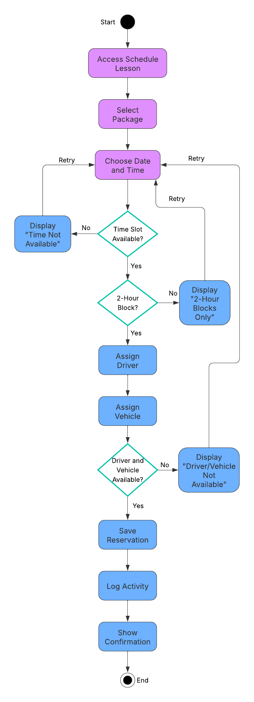
Figure 1: Practice Test Figure 2: Schedule Driving Lesson

UML Sequence Diagram
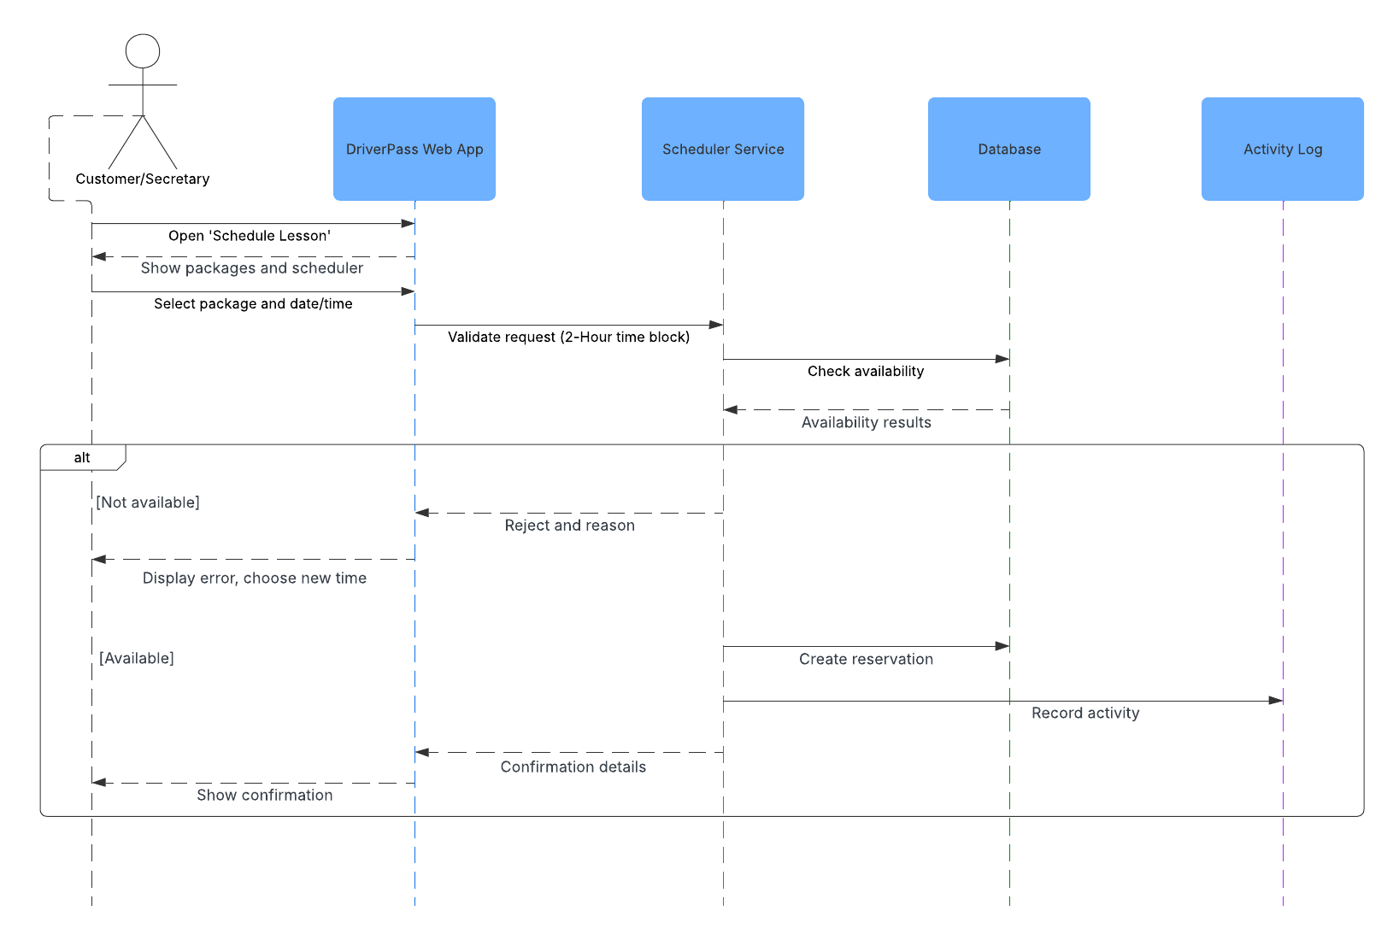

UML Class Diagram

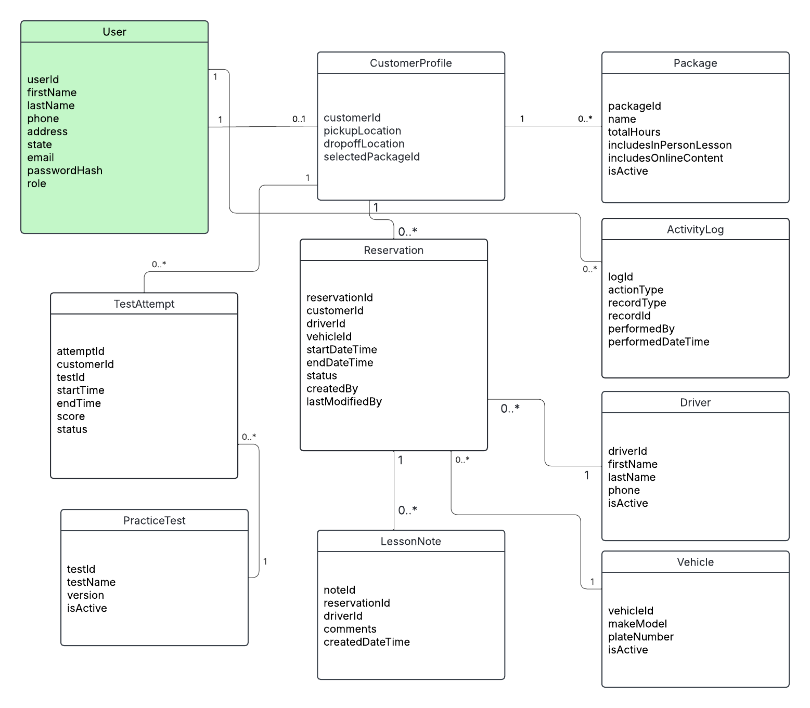

Technical Requirements
Hardware
- Cloud provider managed compute resources to host the web application.
- Cloud provider managed storage for backups and exported reports.
- End user devices: desktop, laptop, tablet, phone with a modern web browser for customers and staff.
Software
- Web application to support online practice tests, scheduling, and account management.
- Relational database to store users, customer profiles, packages, reservations, drivers, vehicles, lesson notes, practice tests, test attempts, and audit logs.
- Reporting and export capabilities for management reporting and offline review.
Tools
- Logging and monitoring tools to support troubleshooting and uptime.
- Version control for development collaboration and change tracking.
- Issue tracking and documentation tool to track requirements, tasks and changes.
Infrastructure
- Role based access control so each user only sees features they are authorized to use.
- Secure authentication and a password reset process managed through the system.
- Audit logging for key actions such as creating, modifying or cancelling reservations.
- Regular automated backup and disaster recovery through the cloud hosting environment.
- Encrypted communication to protect account and scheduling information in transit.

